Firewall Login

IP : 10.0.3.1

User Name : admin

Password : $PFS@tmtlblr38$

System --🡪

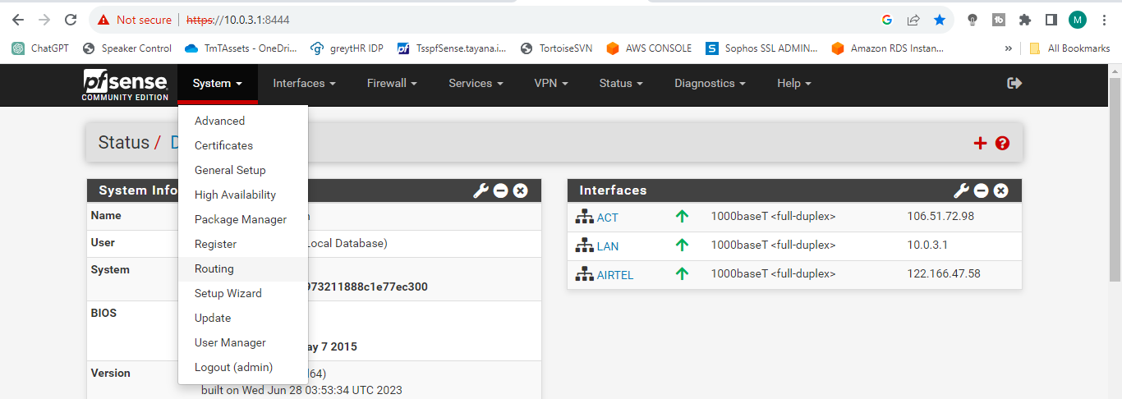

Routing---🡪

Gateway Groups ---🡪

Group Name : ShubhaLoadBalancer

Month First – From - 1-month-year To 15-month-year

Gateway Priority :

ACTGW – Tier 2

WAN_DHCP – Tier 2

AirtelGW – Tier 1

Save --🡪 Apply Changes

Month Mid – From - 16-month-year To 31-month-year

Gateway Priority :

ACTGW – Tier 1

WAN_DHCP – Tier 1

AirtelGW – Tier 2

Save --🡪 Apply Changes